**Online Quiz Portal Using Servlets, JSP, and JDBC**

**Screenshots**

**Welcom Page**

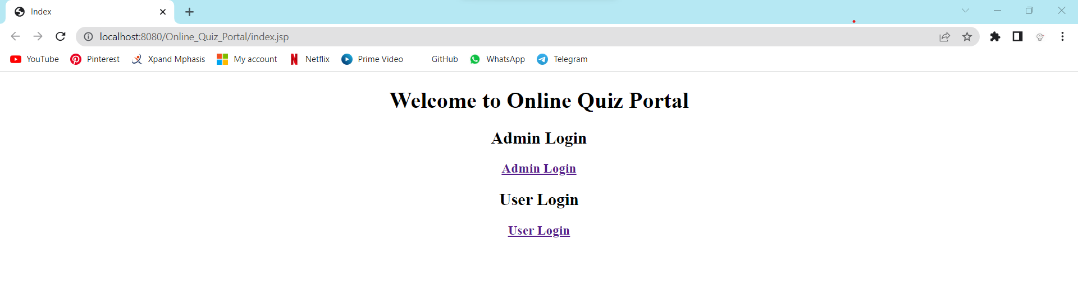

**Admin Login**

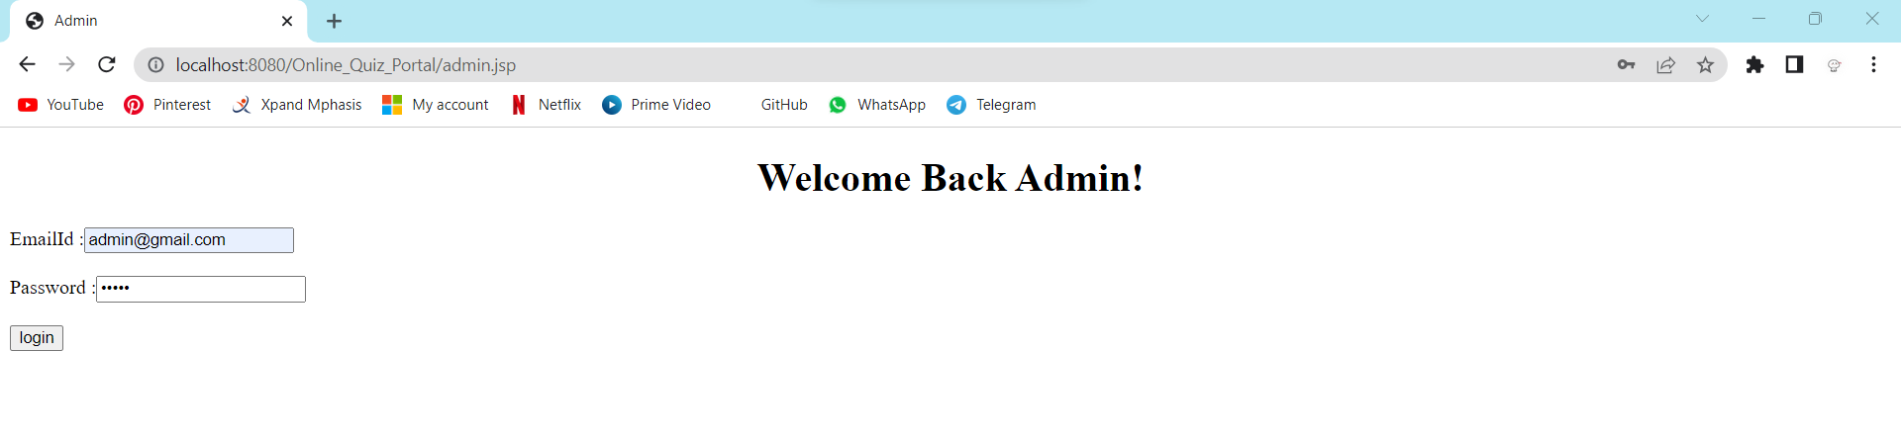

**Invalid Admin credentials**

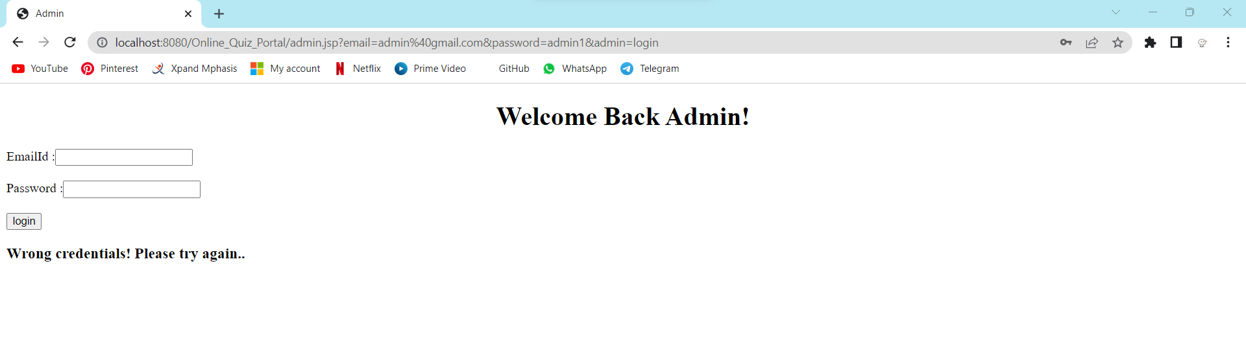

**Admin Dashboard**

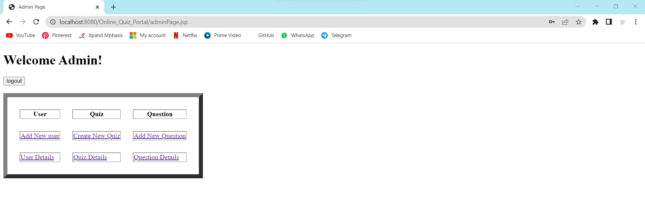

**Add New User**

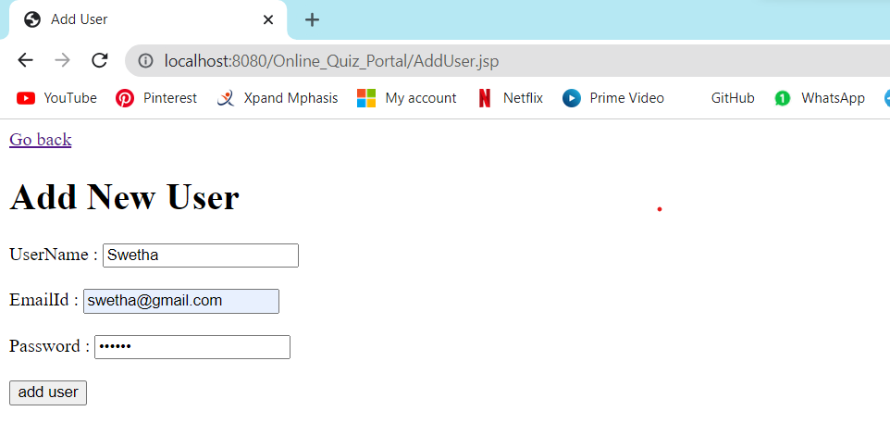

**User Details Added successfully**

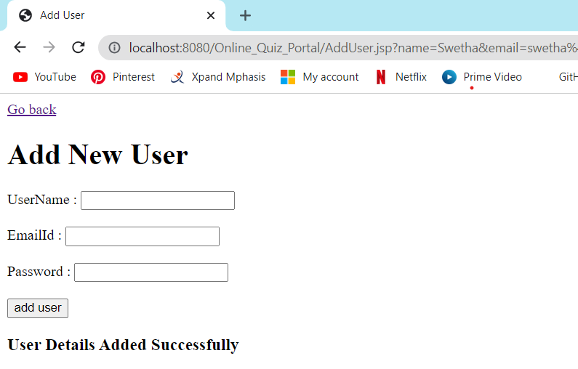

**User Details**

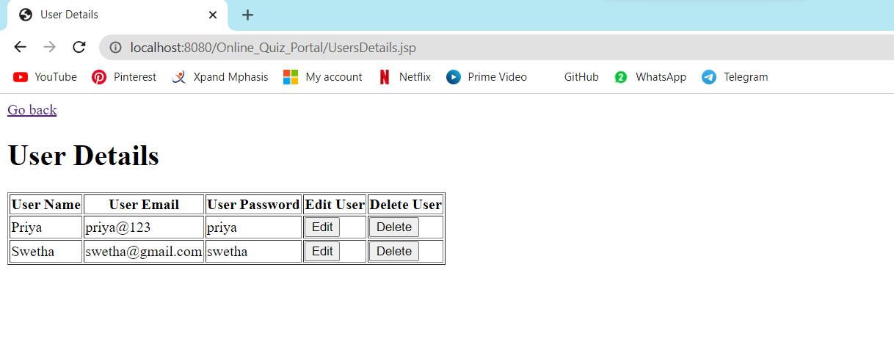

**Edit user details**

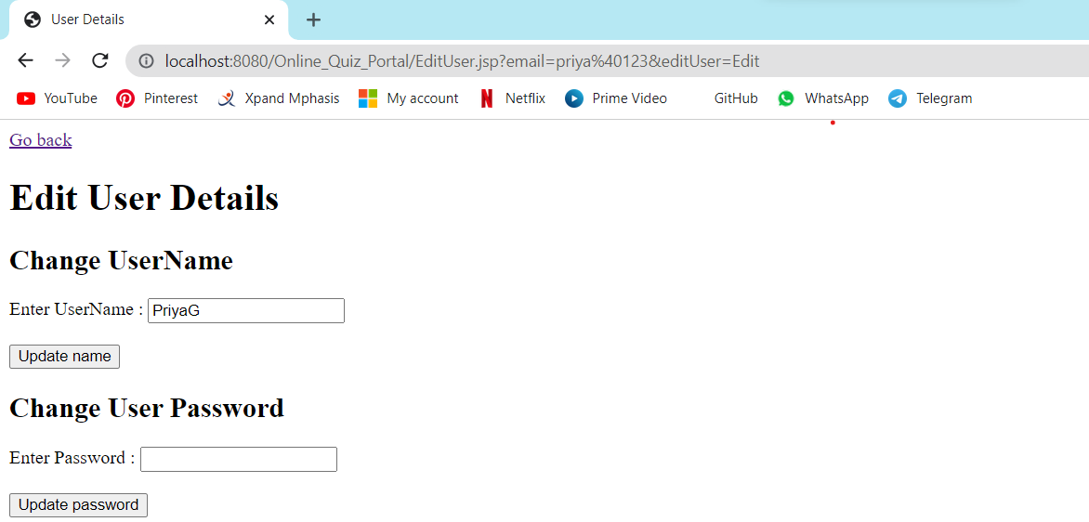

**UserName Updated successfully**

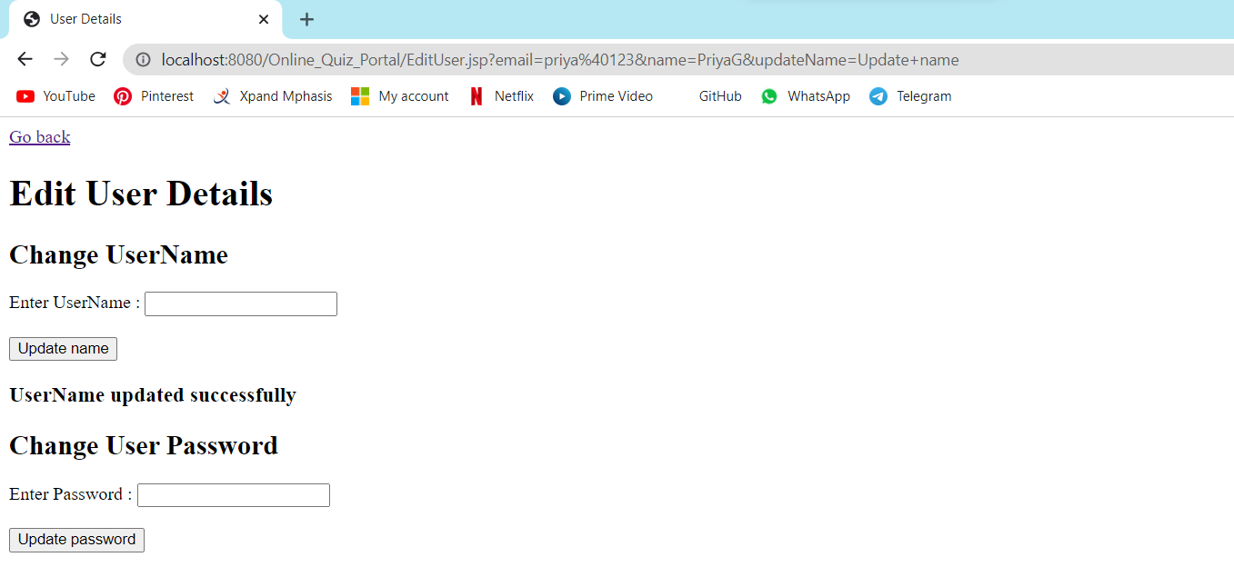

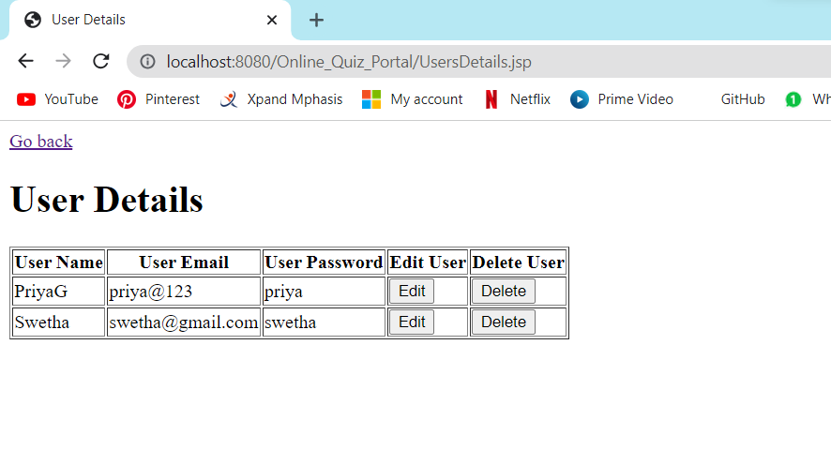

**Delete User**

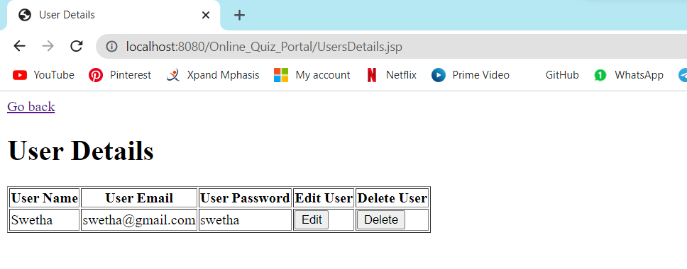

**Create Quiz**

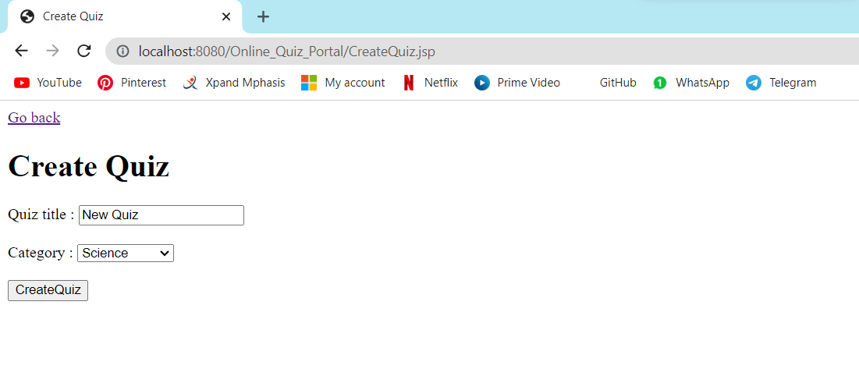

**Quiz Details**

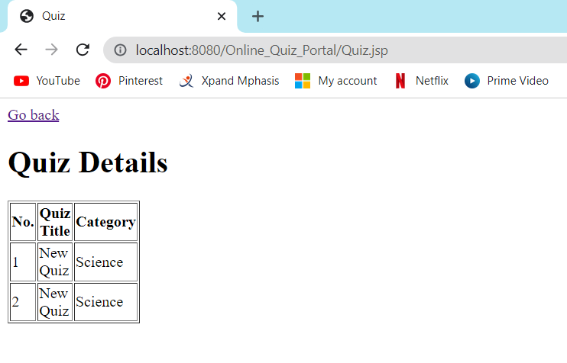

**Add New Question**

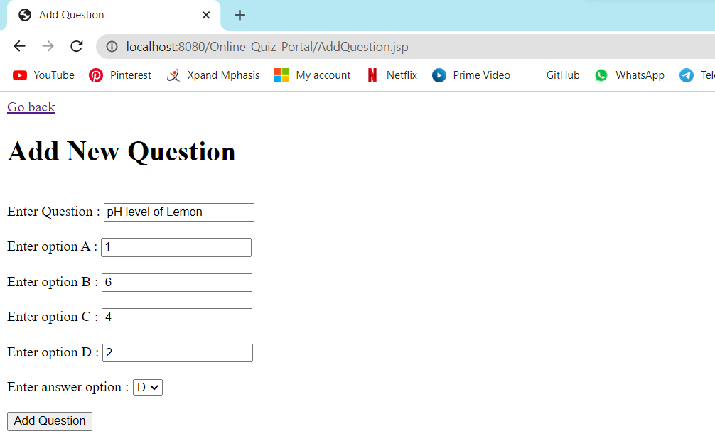

**Question Added successfully**

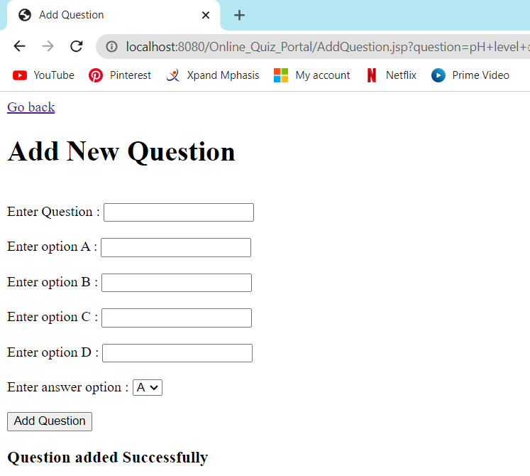

**Edit Question**

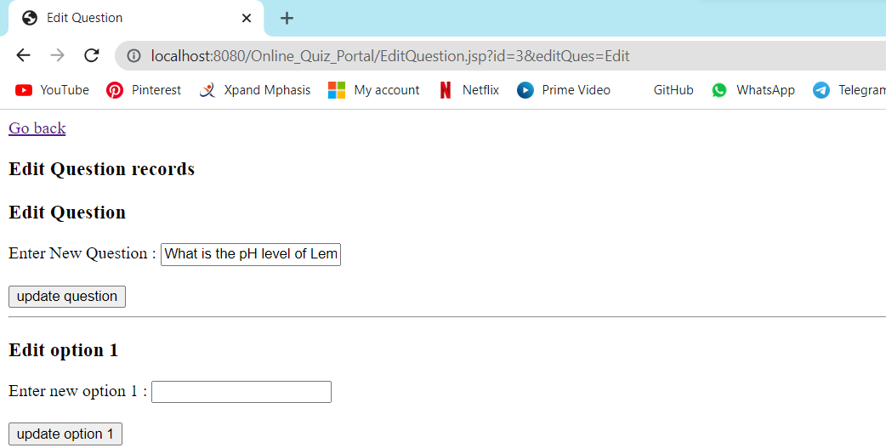

**Updated Quiz details**

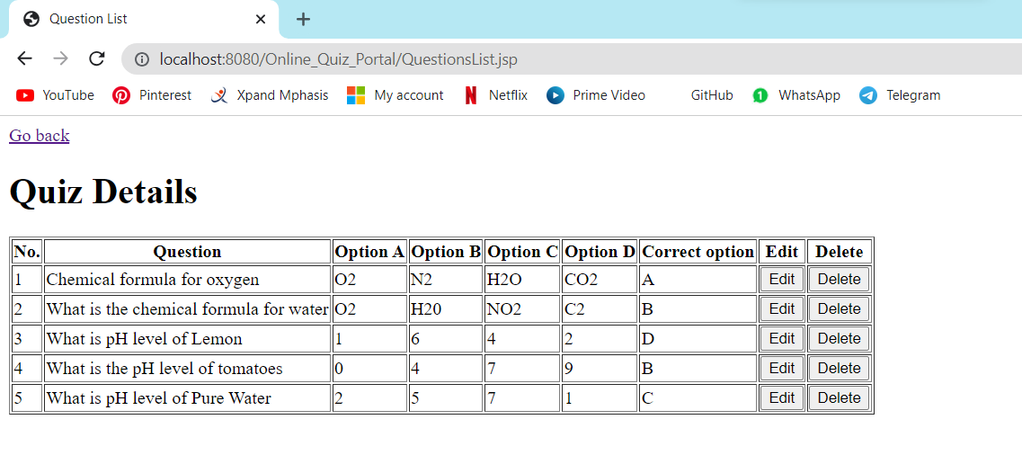

**User Register**

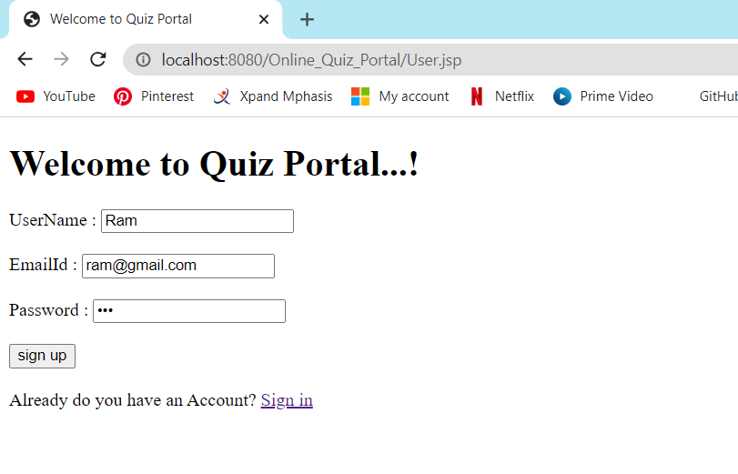

**Quiz portal**

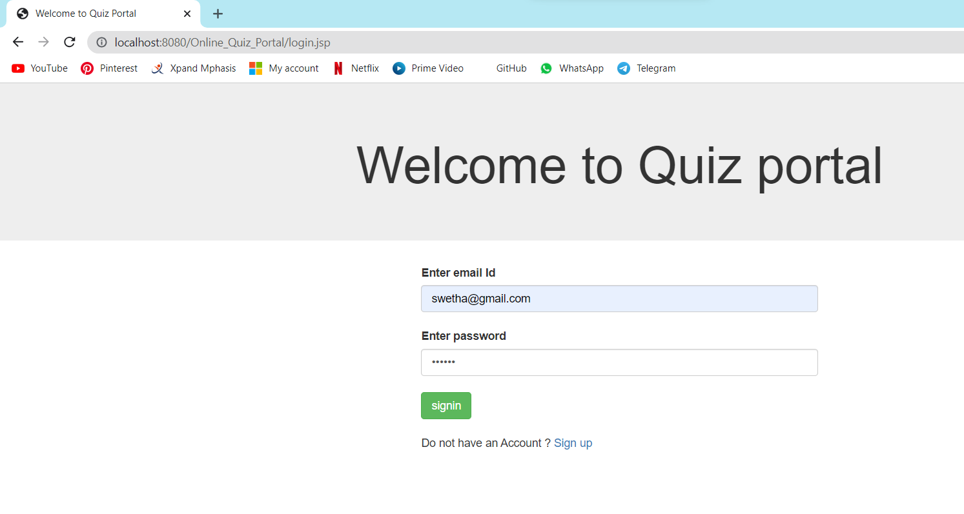

**Quiz Started**

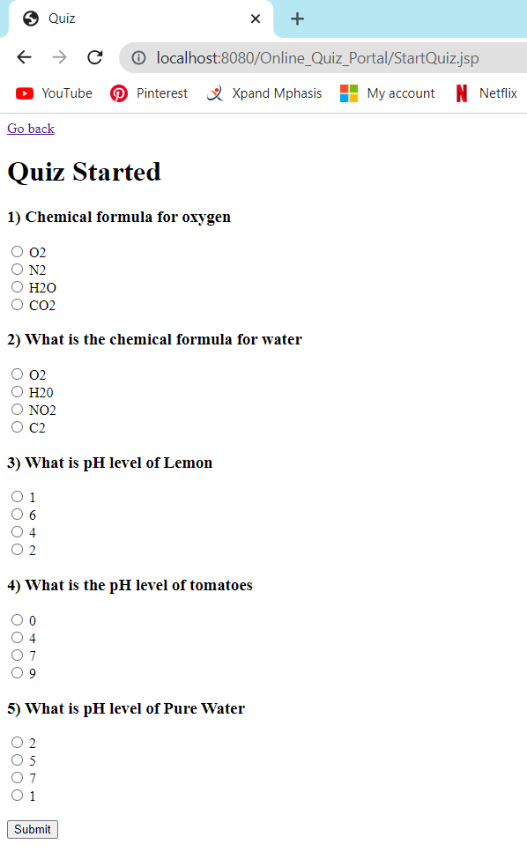

**Quiz Answer**

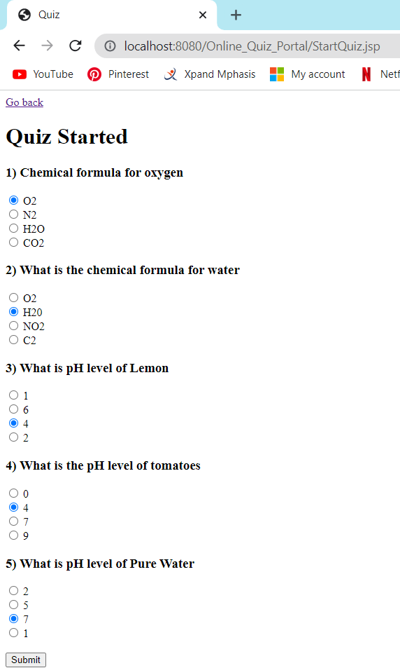

**Quiz Result**

